**PA 307.4.1 - Practice Assignment -**

**Design Online Resume using HTML and CSS**

**Assignment Objective**

In this assignment, you will build your online resume with HTML and CSS.

**Requirements**

The idea is to develop a responsive web resume that you can show to any employer you want to work for. The screenshot below will give you an idea of how a resume should look.

**Desktop Version:**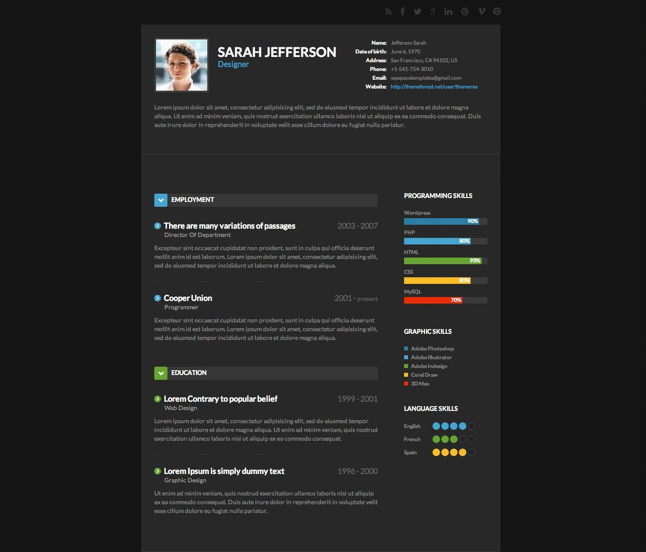

**Mobile Version:**

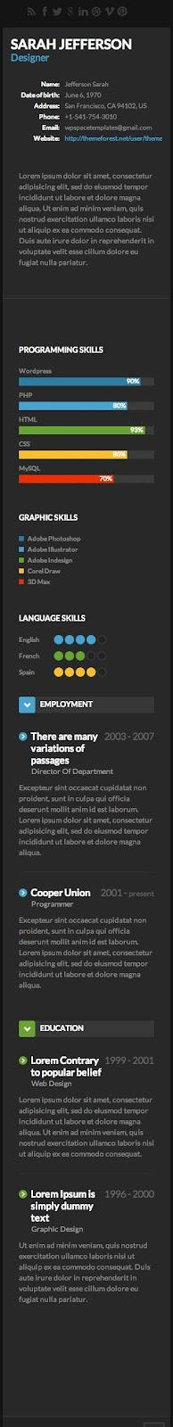

**Suggested Steps:**

1. This may seem overwhelming, but do not worry; we will accomplish it in single steps. For this first step, you just need to lay out the structure of the first session of the resume, which includes an image, your full name, your title, some general information, and a biography. You can always go back and restructure the html. For now, let’s think of one possible structure for this session. Of course, you are welcome to follow your own creative structure:
   1. Think of the entire resume inside a big container. Let’s name the container “main_container.”
   2. Inside main_container, we can have a session where we can put all the information required for this step. Let’s name it “session1.”
   3. Now inside session1, the simplest way to see it is by visualizing three boxes: Box 1) image, full name, and title; Box 2) general information, and Box 3) biography.
   4. Go ahead and start implementing the information in the boxes. After that, play around with the CSS. Although we have not learned about the “display” property of CSS, it is pretty easy to understand, and we encourage you to research it.
2. Now that you see more of CSS such as class, id, selector precedence, display, and position, it is time to move forward. Before we move forward, perform a search on the <aside> tag and the <hr /> tag. Now, almost the same thing applies here from step 1. Think about the session that has “EMPLOYMENT” and “EDUCATION” in one container, and a session with “PROGRAMMING SKILLS,” “GRAPHIC SKILLS,” and “LANGUAGE SKILLS” in another container. This is about creating the correct structure inside the two containers. *Hint: the container with the percentages and the circles are all boxes that are styled correctly! Go ahead and let your creativity shine.*
3. Now that you have the structure ready, begin styling your online resume to look more like the photo above. When styling your resume, use five different ways of selecting an HTML element (including id, and class). If you have been using internal styling, move everything to an external style sheet.

**Submission Instructions:**

Include the following deliverables in your submission -

* + Submit your source code or screenshots using the Start Assignment button in the top right corner of the assignment page in Canvas.

| **Instructions for Canvas Assignment Creation** |
| --- |
| **Assignment Name: PA 307.4.1 - Practice Assignment - Design Online Resume using HTML and CSS**  **Points: 100**  **Assignment Group: Module 307 - Fundamentals of HTML/CSS (Not graded)**  **Display Grade As: Complete/Incomplete**  **Do not count this assignment towards the final grade: Checked**  **Submission Types: File Upload Everything else is the default.** |